
Egypt University of Informatics
Computer and Information Systems
Data Analysis Course

The Analysis of Electric Vehicle Adoption Factors
Submitted by:
Belal EL Shammaa 24-101461
Mohamed Emad 23-101018
Ahmed el bosaty 23-101241
Youssef Hesham 24-101088
11/5/2024

Introduction

The transition from petrol vehicles to electric vehicles (EVs) has become a global priority due to environmental concerns, rising fuel costs, and technological advancements. Governments and industries are increasingly investing in EV infrastructure and incentives to accelerate adoption.
Understanding the factors that influence EV adoption is crucial for policymakers, businesses, and consumers. This report analyses how economic conditions, infrastructure availability, and government policies impact the adoption of electric vehicles.

Research Question
What are the key factors influencing electric vehicle (EV) adoption, and how do economic, infrastructure, and policy variables affect EV market share?

Hypothesis
Main Hypothesis:
EV adoption is driven by a combination of economic factors, infrastructure availability, and government policy support.

Sub-Hypotheses:
- H1: Higher fuel prices lead to higher EV market share.
- H2: Increased charging infrastructure leads to higher EV adoption.
- H3: Government subsidies positively influence EV market share.
- H4: Higher GDP per capita leads to higher EV adoption

Population of Interest:
The population of interest includes countries and regions represented in the dataset, covering various economic conditions, infrastructure levels, and policy environments related to electric vehicle adoption.

Sampling Method:

The dataset used in this analysis is collected from publicly available sources and represents multiple countries over different time periods. The sampling method can be considered observational sampling, where real-world data is gathered without manipulation.

This approach is appropriate as it reflects actual market behaviour and allows for realistic analysis of EV adoption trends.

Bias Identification:
Potential sources of bias include:
- Geographical bias: Some regions may be overrepresented.
- Economic bias: Wealthier countries may dominate the dataset.
- Data availability bias: Countries with better reporting systems may have more data.
To minimize bias:
- Multiple variables were analysed instead of relying on a single factor.
- Trends were interpreted cautiously without overgeneralization.

Survey Questions/Collected Data/Dataset:
The dataset contains information about electric vehicle adoption and influencing factors across different regions.
Key Variables:
- ev_sales: Number of electric vehicles sold
- total_vehicle_sales: Total number of vehicles sold
- ev_market_share: Percentage of EVs in total sales
- fuel_price_usd_per_liter: Cost of fuel
- charging_stations: Number of EV charging stations
- ev_subsidy_usd: Government subsidy for EV purchase
- gdp_per_capita: Economic indicator of wealth
Number of samples used: 1200

Analysis:
To analyse the dataset, descriptive statistics and visualizations were used to identify patterns and relationships between EV adoption and influencing factors.
Distribution of EV Market Share
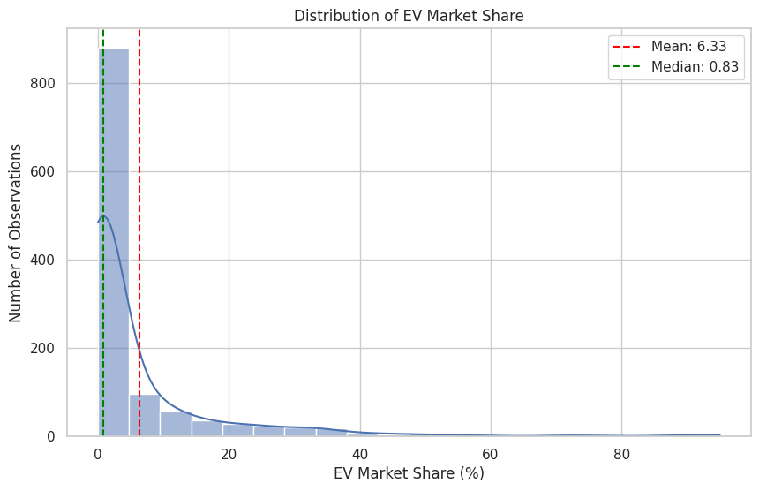
The histogram illustrates the distribution of EV market share across all observations. Most values are concentrated in the lower range, indicating that EV adoption remains relatively low in many regions.
However, a few observations show high EV market share, suggesting that some regions have significantly advanced in EV adoption.
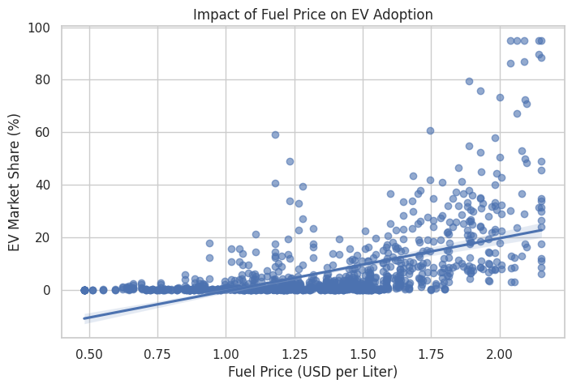
Fuel Price vs EV Market Share

This graph shows the relationship between fuel prices and EV market share. A positive trend can be observed, where higher fuel prices are associated with increased EV adoption.
This suggests that rising fuel costs encourage consumers to shift toward electric vehicles as a cost-saving alternative.

Charging Stations vs EV Market Share
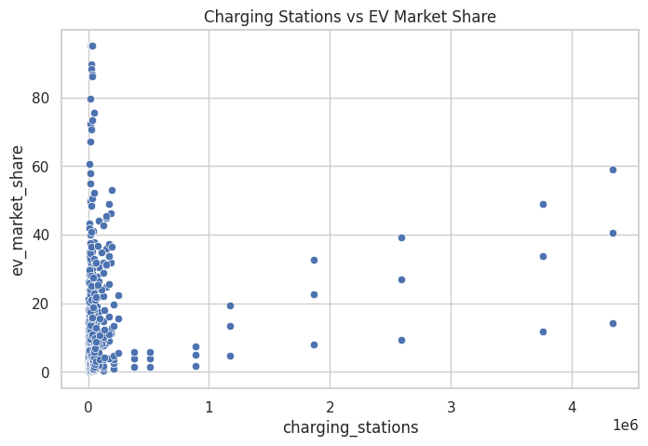
The graph demonstrates a positive relationship between the number of charging stations and EV market share. Regions with more developed charging infrastructure tend to have higher EV adoption.
This highlights the importance of infrastructure availability in supporting EV usage.
Subsidy vs EV Market Share
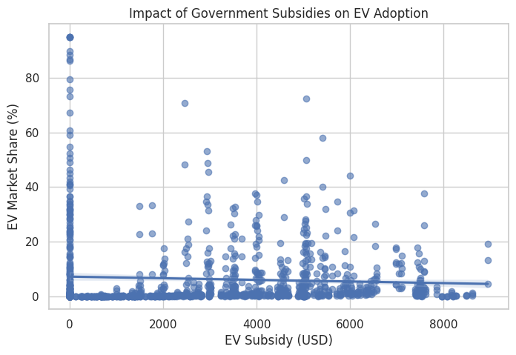
The visualization indicates that higher government subsidies are associated with increased EV market share. Financial incentives appear to reduce the cost barrier and encourage adoption.
GDP vs EV Market Share
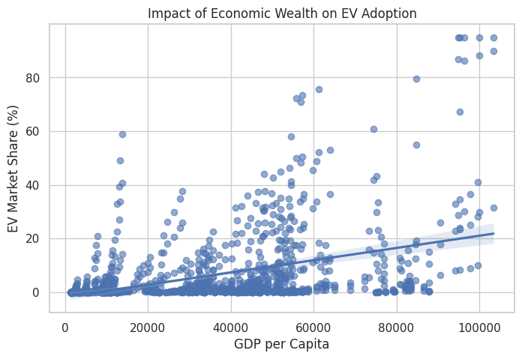
This graph shows that regions with higher GDP per capita tend to have higher EV market share. Wealthier populations are more likely to adopt EV technology due to affordability and access.
Correlation Heatmap
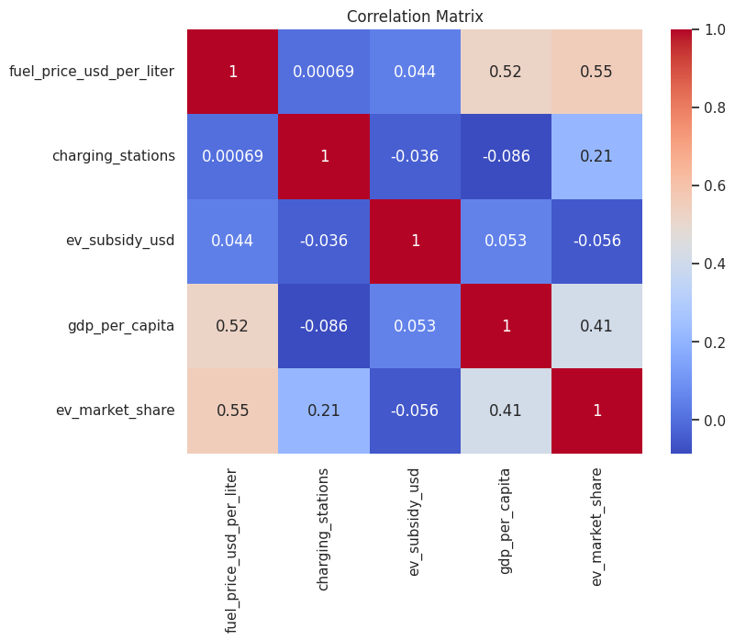
The correlation matrix shows relationships between all variables. EV market share is positively correlated with fuel prices, charging stations, subsidies, and GDP.
This supports the idea that EV adoption is influenced by multiple factors rather than a single variable.
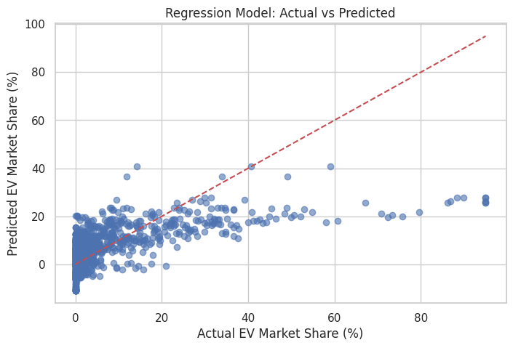
Regression Model (Combined Factors)

This graph compares the actual EV market share with the predicted values from the regression model. The closer the points are to the reference line, the more accurate the model is.
The results indicate that EV adoption can be reasonably predicted using a combination of fuel prices, charging infrastructure, subsidies, and GDP per capita. This supports the main hypothesis that EV adoption is influenced by multiple factors rather than a single variable.
While individual graphs showed the effect of each variable separately, the regression model confirms that these factors collectively influence EV adoption.

Hypothesis Testing Steps
- Step 1: Define the main and sub-hypotheses related to EV adoption.

- Step 2: Visualize relationships between EV market share and each independent variable using graphs.

- Step 3: Analyse correlations and trends observed in the data.

- Step 4: Evaluate whether the observed relationships support or reject the hypotheses.

Conclusion
The analysis indicates that EV adoption is influenced by a combination of economic, infrastructure, and policy factors. All sub-hypotheses show positive relationships with EV market share to varying degrees.

However, no single factor fully explains EV adoption. Instead, a combination of high fuel prices, strong infrastructure, supportive policies, and economic strength contributes to higher EV adoption levels.

Any potential issues
- Some variables may not capture all real-world influences (e.g., consumer behaviour).

- The dataset may not fully represent all countries equally.

- Correlation does not imply causation; relationships observed do not guarantee direct causality.

- Missing or estimated data may affect accuracy.

